**PyGraphing Calculator - User Guide**

This calculator program allows the user to perform normal calculations found on a scientific calculator, graph functions of x, integrate, and find Riemann Sums. A table of values for a function can also be created in addition to the graph.

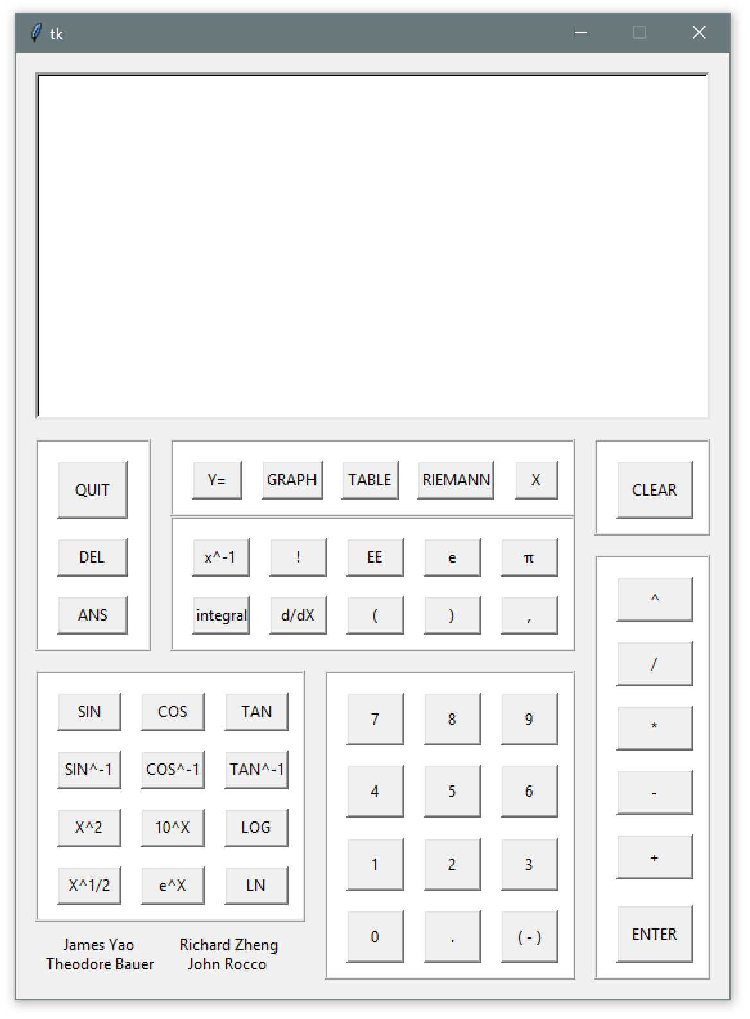

**Scientific Calculations:**

When the calculator starts, any correctly formatted expression can be solved by entering it immediately into the display via the buttons. This input is displayed at the top center of the display.

When the **ENTER** button is pressed, the input expression is displayed on the left and the output on the right side of the display.

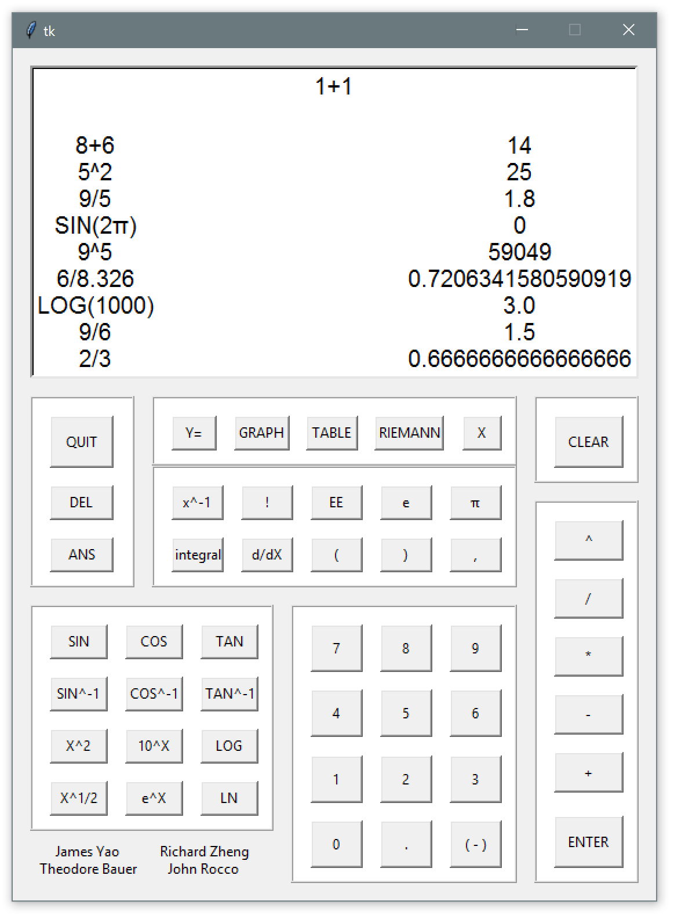

Properly formatted expressions follow the basic rules of mathematics, and all parentheses are closed.

Carets signify the power function. Elements immediately after the caret are the exponents.

An **ERROR** is displayed as the output when an arithmetic expression cannot be evaluated.

The **CLEAR** button clears all inputs and previously logged calculations.

The **ANS** button inputs the previous answer into the input area, unless the previous output was an **ERROR**.

The **DEL** button removes the last character in the input area.

The **QUIT** button returns the user to the scientific calculations frame and exits the program if pressed while already at the scientific calculations frame.

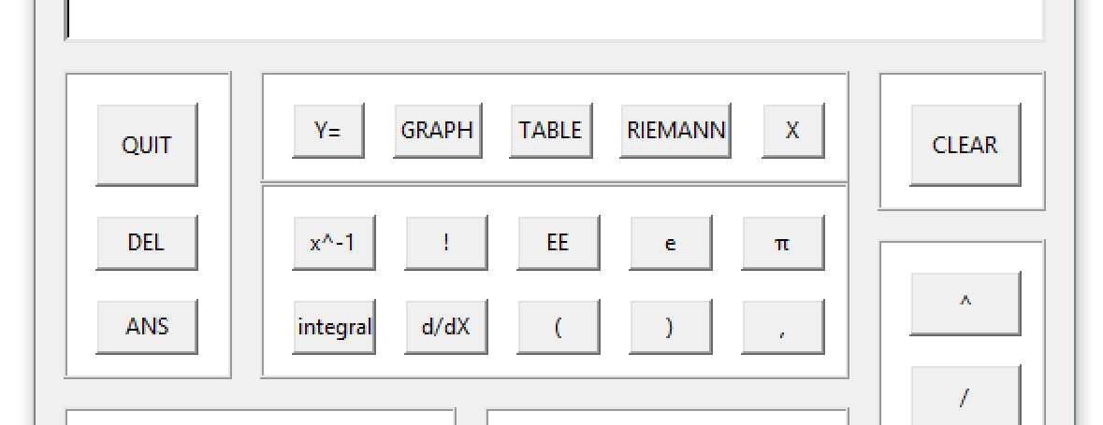

**Calculus Tools:**

Integration and Differentiation tools are included in this graphing calculator. The user may use the **integral** and **d/dX** buttons for general calculations and also in the **Y=** display.

To calculate an integral, the user must follow this format:

***integral(f(X), lowerBound, upperBound)***

Derivatives follow the format below (X being the point at which the user wishes to evaluate the derivative):

***d/dX(f(X), X)***

As long as the rules of mathematics are followed, these can be entered and treated as numeric values (and also calculated inside of each other).

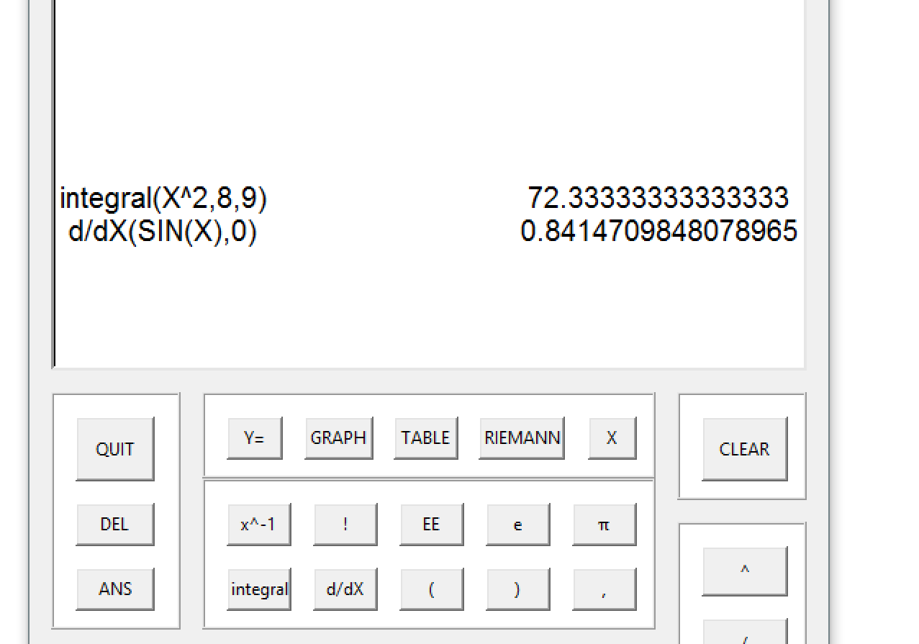

**Function Tools:**

The **Y=** button brings the user to the function frame, where a function of the variable X may be entered. The calculator buttons can be used to create any function. The user can also enter **Bounds** and an **Interval**, which will play roles in the **GRAPH**, **TABLE**, and **RIEMANN** screens. The **QUIT** button will bring the user to the scientific calculations frame.

The **GRAPH** button will open a new window displaying a graphical representation of the function entered in the **Y=** screen. The domain will be determined by the previously entered **Bounds**.

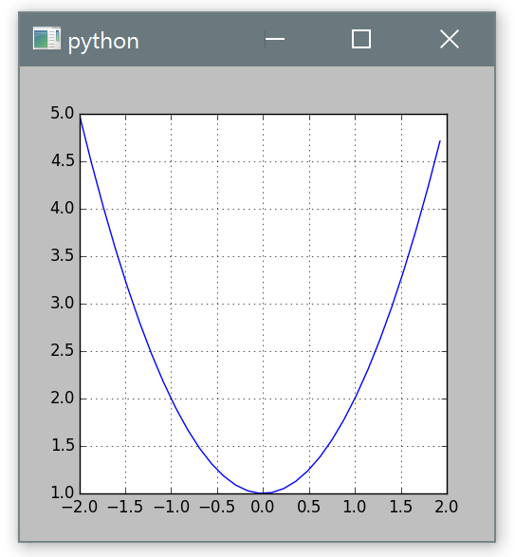

The **TABLE** button displays the first 5 values of **X** and **Y** from the **Left Bound**, stepped by the **Interval**. A function must have already been entered into this frame. The table occupies the function frame.

The **CLEAR** button will clear the existing graph. The **QUIT** button will bring the user to the scientific calculations frame.

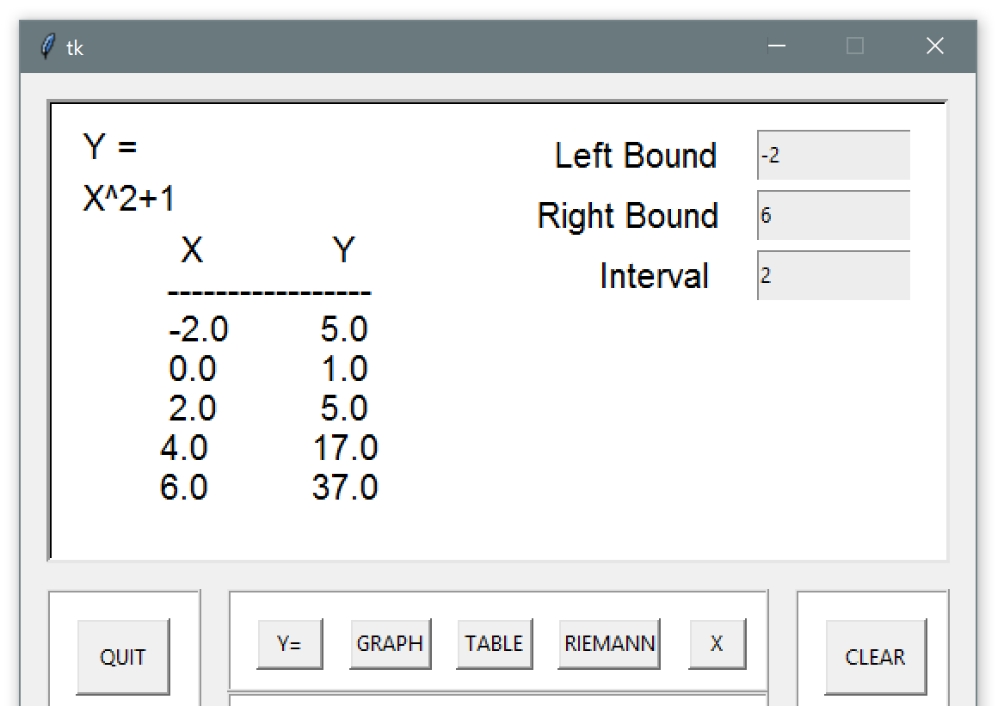

The **RIEMANN** button will display the Riemann frame, where the user can enter the type of Riemann sum (“midpoint”, “left” or “right”). The user may then click the smaller **ENTER** button inside the display, and the Riemann sum of the function entered in **Y=** will be calculated. The **QUIT** button will bring the user to the scientific calculations frame.

